**DESIGN AND IMPLEMENTATION OF A TELEMETRY AND DISPLAY SYSTEM FOR MOTORSPORT APPLICATIONS USING CONTROLLER AREA NETWORK COMMUNICATION**

*An Undergraduate Project Report submitted to Manipal University*

*Submitted by*

**ADITYA VIKRAM JINDAL VARUN SACHDEVA**

(Reg. No 180907586) (Reg. No 18932522)

BACHELOR OF TECHNOLOGY

In

ELECTRONICS AND COMMUNICATION ENGINEERING

And

ELECTRONICS AND INSTRUMENTATION ENGINEERING

**MANIPAL INSTITUTE OF TECHNOLOGY**

**INTRODUCTION**

This project report describes the design and working of a Motorsport Data Acquisition System,Live Telemetry System and Display system developed using the Controller Area Network (CAN) communication protocol as the backbone of the system. A Formula One car hosts over a hundred sensors during each of its races. The Data Acquisition System, although does not directly affect the car’s performance, is an indispensable system when it comes to improving and testing designs. Designers can validate their assumptions and calculations, real-time data during testing can be a safety indicator and it provides insight to the driver about the performance of the vehicle.

**OBJECTIVES**

The proposed work is to design and implement a Data Acquisition and Telemetry System to be on-board a race car. The major objectives include

* Establish a modular Controller Area Network bus which runs throughout the vehicle.
* Interfacing multiple nodes to the said CAN bus, each with their own functionalities.
* Transmitting the data of multiple sensors onboard the vehicle.
* Display valid data to the driver while operating the car.
* Wireless data transmission back to host across a long range.

**SYSTEM OUTLINE**

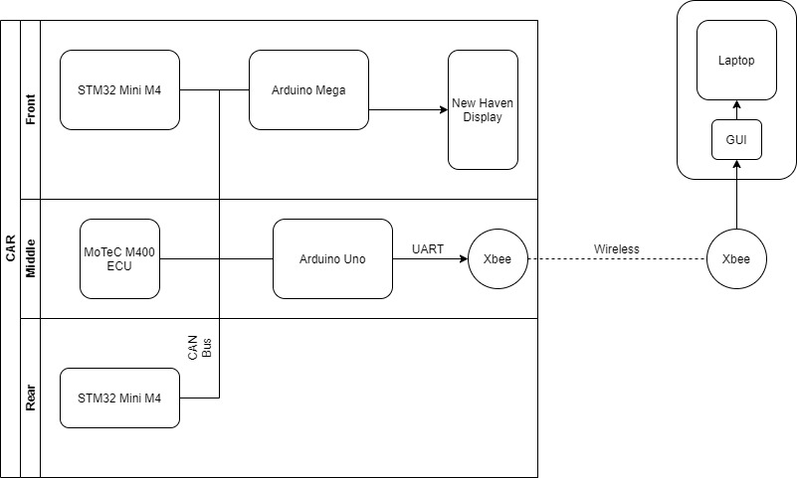

**THEORY**

This part concentrates on the literature survey involved in designing the system.

**THE NEED FOR DATA ACQUISITON AND TELEMETRY IN MOTORSPORTS**

A design is only as good as the performance of the part in field and in tests, but to judge whether a part/system is behaving like it is supposed to Data from different sensors monitoring different physical parameters are required to validate the design. A Data Acquisition and Telemetry System helps analyse the vehicles behaviour during different tests and set ups.

Simulations can predict a certain parts behaviour but to ensure proper results and safety such a system is a must.

A Telemetry System also helps you analyse your driver’s performance. Looking at real-time data while your driver is on the track can help give invaluable feedback to improve performance.

Lastly, Motorsport is a continuous improvement process. Logged data helps designers avoid the mistakes their predecessors committed or take useful information out of their successes.

**WHY CONTROLLER AREA NETWORK?**

Controller Area Network is a multi-master, message broadcast system that allows a maximum signalling rate of 1 megabit per second(bps). In a CAN network, many short messages like temperature or RPM are broadcast to the entire network, which provides for data consistency in every node of the system. The protocol is a motorsport and commercial industry standard due to its modular and 2-wire physical bus which has led to the replacement of complex wiring harnesses.

Additionally, Controller Area Network sends specialized standard CAN Message formats which allow up to 8 bytes of data per message each with their own 11-bit identifier which decide the message arbitration and prevent message collision.

**DESIGN CONSIDERATIONS**

the main factors that were taken into consideration before picking any component

1. Ability to withstand the harsh motorsport environment
2. Ease of programming and interface
3. CAN compatibility and other communication protocol compatibility.
4. Ability to self-diagnose and repair data errors and physical layer errors.

**COMPONENTS**

1. **MoTeC M400 ECU**

The MotecM400 engine control unit is a part of the Hundred Series of the MoTeC ECU's. It is specifically designed for a four-cylinder engine. It provides multiple features for engine tuning and management and also supports CAN protocol. It is connected to various Engine sensors in the car and transmits their data to the CAN bus.

1. **STM32 Mini M4**

The STM32 Mini M4 is a development Board fitted with STM32f415RG microcontroller powered by ARM cortex. The Mini M4 was chosen because the board comes fitted with 15 Analog Input Pins, an inbuilt CAN Controller and has a very compact form factor. The system Utilises 2 such boards, one positioned in the front and one in the rear of the vehicle, to collect data from all the non-engine sensors (ECU sensors), format them into appropriate CAN messages and transmit them onto the CAN bus.

1. **Arduino Uno**

Arduino Uno is a microcontroller board based on the Atmega328P microcontroller. The board has 14 digital I/O pins and 6 Analog input pins. A can controller (MCP2515) is connected to this board via SPI which enables it to communicate through the CAN bus. Its role in the system is to collect data from the CAN bus and transfer it to the XBEE module via UART.

1. **Arduino Mega**

Arduino Mega is a microcontroller board based on the Atmega2560 microcontroller. The board has 54 digital I/O pins and 16 Analog input pins. A can controller (MCP2515) is connected to this board via SPI which enables it to communicate through the CAN bus. Its role in the system is to control the display. It receives data from the CAN bus and transfers it to the display using an 8 bit data bus.

1. **Xbee Pro 900 Hp**

The Xbee modules are used to transfer data wirelessly from the car to the laptop for live telemetry. They have a frequency band of 902 to 928 MHz and RF data transfer rate of 10Kbps for up to 610m indoor or 15.5km outdoor and 200Kbps for up to 305m indoor and 6.5km outdoor.

1. **New Haven Display**

This display is a 240 x 128 LCD module which is controlled by and receives data from the Arduino Mega.

**SENSORS**

Motorsport/Automotive grade sensors were picked for the system. Temperature considerations, ruggedness, accuracy, and ease of interfacing with the different components helped us narrow down products. Ratio metric voltage output products were preferred.

